**WEEK-6**

**REACT**

**1.ReactJS-HOL**

**1.ReactJS-HOL**

**Objectives**

**What is SPA (Single Page Application)?**

SPA is a web app that loads a single HTML page and dynamically updates content without refreshing the page.

**What is React?**

React is a JavaScript library for building user interfaces, mainly used for SPA.

Created by Facebook, React uses components to manage parts of the UI.

**SPA vs MPA**

| **Feature** | **SPA** | **MPA** |
| --- | --- | --- |
| Load Style | Loads a single HTML page | Multiple pages loaded per request |
| Speed | Faster after initial load | Slower (reload for every page) |
| Routing | Handled on client side | Handled on server side |
| SEO | Harder without SSR | Easier for search engines |

**Pros & Cons of SPA**

**Pros:**

* Fast user interactions
* Fewer server requests
* Smooth transitions

**Cons:**

* Poor SEO without SSR
* Initial load time can be high
* JavaScript dependency

**Virtual DOM**

React uses a **Virtual DOM**, which is a lightweight copy of the real DOM.

It updates only the changed parts efficiently instead of re-rendering the whole page.

**Features of React**

* Component-based architecture
* Virtual DOM
* Unidirectional data flow
* JSX (HTML in JavaScript)
* Reusable components

**CODE:**

**Step1:** **Install create-react-app**

In your command prompt or terminal: npm install -g create-react-app

**Step 2: Create your first React app**

In cmd : npx create-react-app myfirstreact

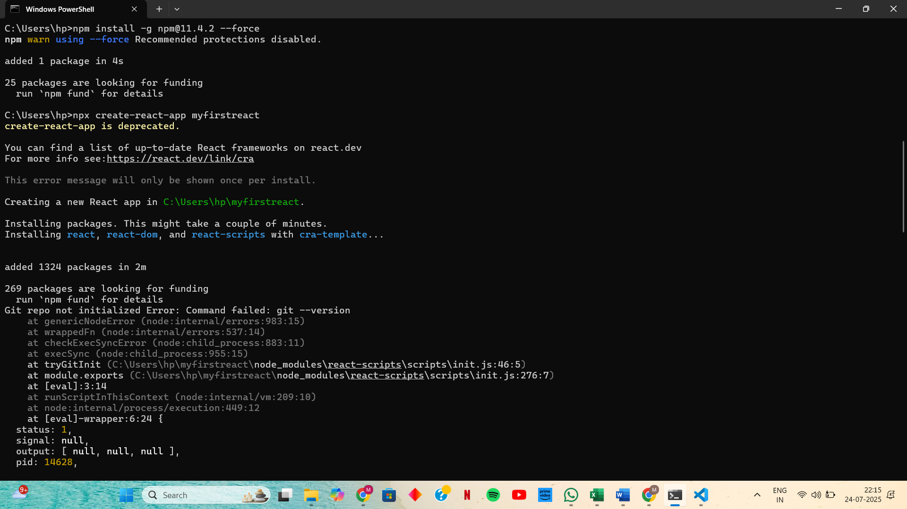

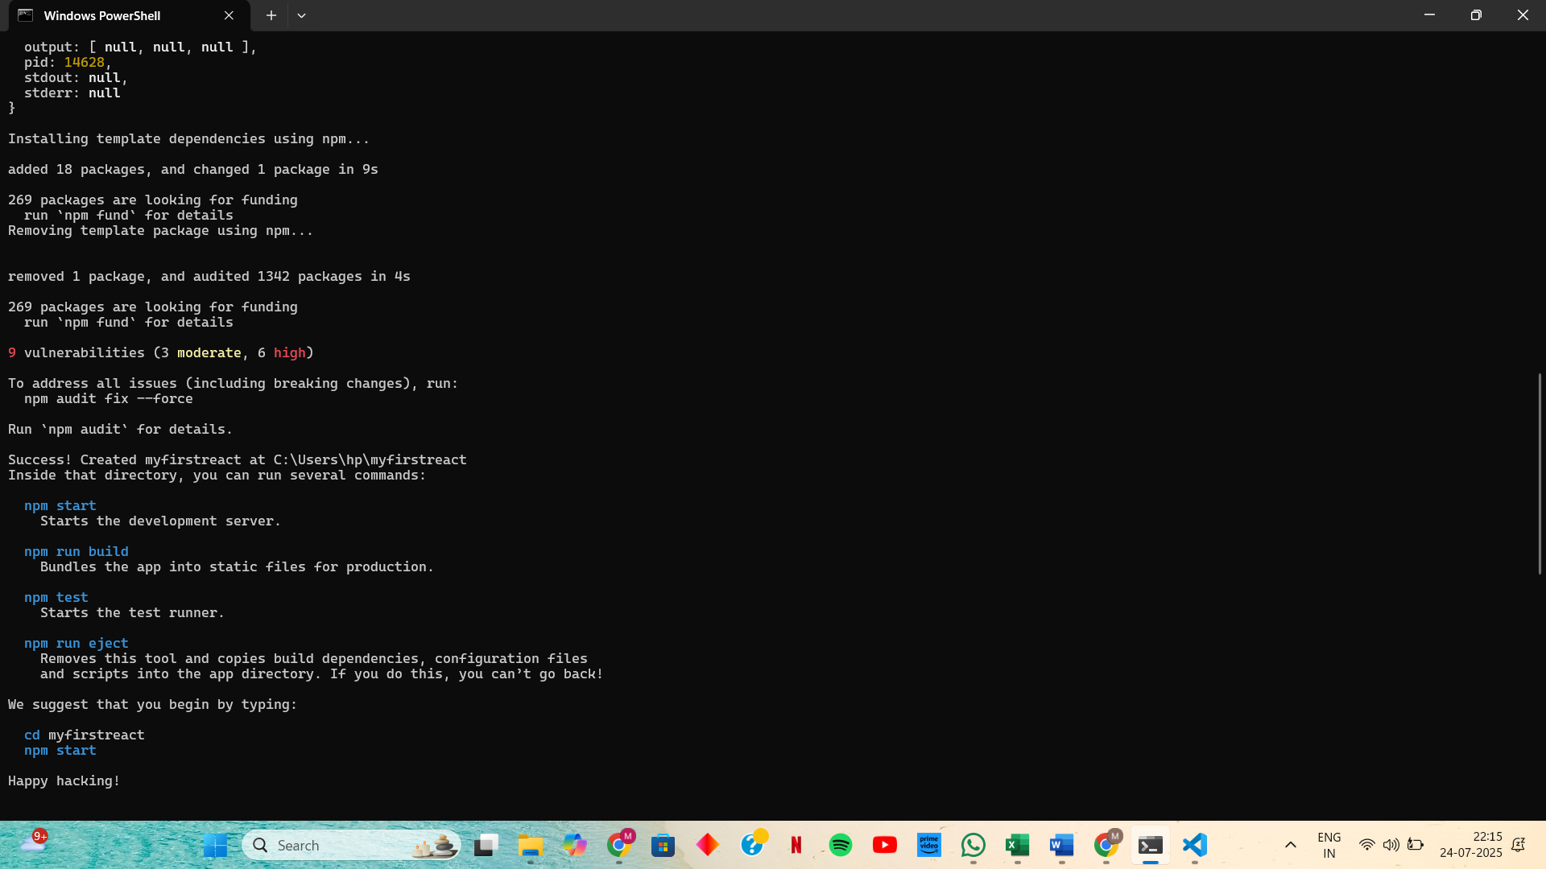

**Step 3: Navigate into project folder by: cd myfirstreact**

**Step 4: Open project in Visual Studio Code and edit App.js**

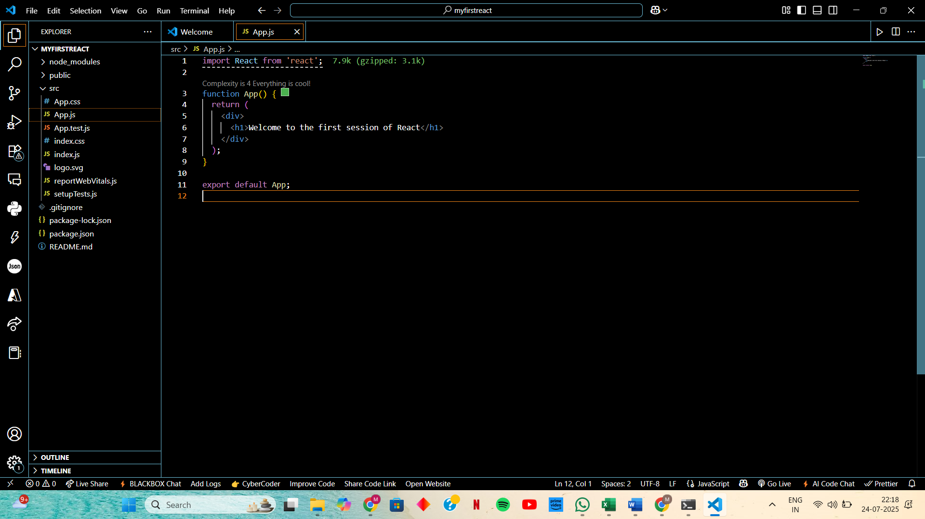

**Step 6: Start the application**

In terminal inside your project folder (myfirstreact), run:

**npm start**

**OUTPUT:**

